**2017**

1. Define specific resistance and state its SI unit [2 marks]
2. An electric bulb of resistance 500 Ω, draws a current of 0.4 A. calculate the power of the bulb and the potential difference at its end [2 marks]

**2016**

1. The V-I graph for a series combination and for a parallel combination of two resistors is shown in the figure below. Which of the two ‘A’ or ‘B’ represents the parallel combination. Give a reason for your answer [2 marks]

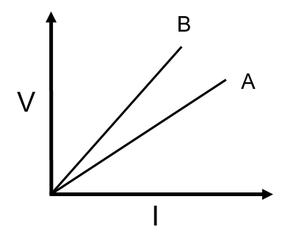

1. A music system draws a current of 400 mA when connected to a 12 V battery.
   1. What is the resistance of the music system
   2. The music system is left playing for several hours and finally the battery voltage drops and the music system stops playing when the current drops to 320 mA. At what battery voltage does the music system stop playing [2 marks]
2. Calculate the quantity of heat produced in a 20 Ω resistor carrying 2.5 A current in 5 min [2 marks]
3. A battery of emf 12 V and internal resistance 2 Ω is connected with two resistors A and B of resistance 4 Ω and 6 Ω respectively joined in series.

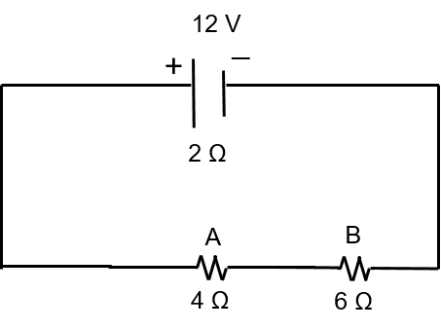

Find

* 1. Current in the circuit
  2. The terminal voltage of the cell
  3. The potential difference across 6 Ω resistor
  4. Electrical energy spent per minute in 4 Ω resistor

**2015**

1. Find the equivalent resistance between points A and B [2 marks]

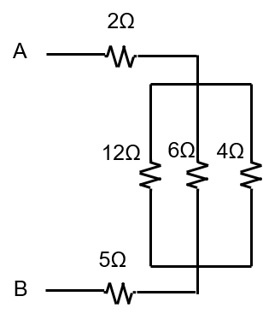

1. The relationship between the potential difference and the current in a conductor is stated in the form of a law
   1. Name the law
   2. What does the slope of V-I graph of a conductor represent
   3. Name the material used for making the connecting wire used [3 marks]
2. A cell of emf 2 V and internal resistance 1.2 Ω is connected with an ammeter of resistance 0.8 Ω and two resistors of 4.5 Ω and 9 Ω as shown in the diagram below

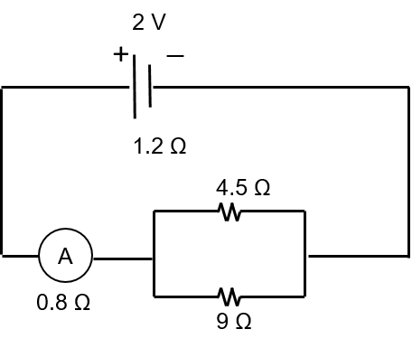

* 1. What would be reading on the ammeter
  2. What is the potential difference across the terminals of the cell [4 marks]

**2014**

1. Find the equivalent resistance between points A and B [2 marks]

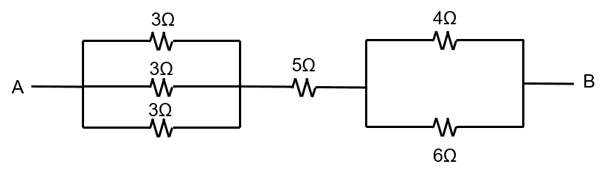

1. (i) What is an ohmic resistor

(ii) Two copper wires are of the same length, but one is thicker than the other

1. Which wire will have more resistance
2. Which wire will have more specific resistance [3 marks]
3. What is consumed using different electrical appliances, for which electricity bills are paid [1 mark]

**2013**

1. Calculate the equivalent resistance between the points A and B for the following combination of resistors [2 marks]

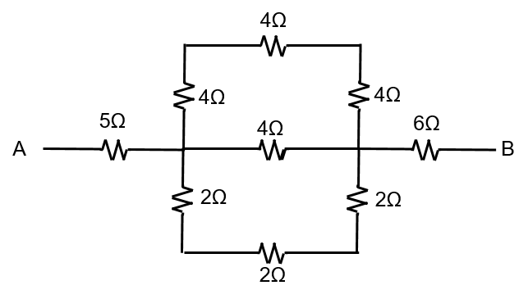

1. (i) State ohm’s law

(ii) A metal wire of resistance 6 Ω is stretched so that its length is increased to twice its original length. Calculate its new resistance [3 marks]

1. The figure shows a circuit, when the circuit is switched on, the ammeter reads 0.5 A

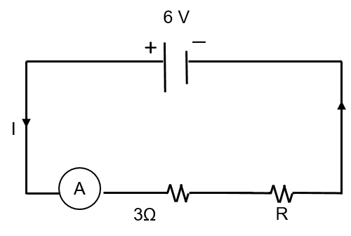

* 1. Calculate the value of the unknown resistor, R
  2. Calculate the charge passing through the 3 Ω resistor in 120 s
  3. Calculate the power dissipated in the 3 Ω resistor [4 marks]

**2012**

1. Calculate the equivalent resistance between P and Q from the following diagram [2 marks]

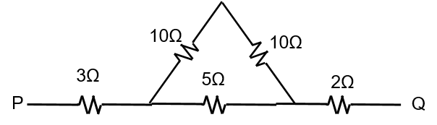

1. Three resistors are connected to a 6 V battery as shown in the figure. Calculate

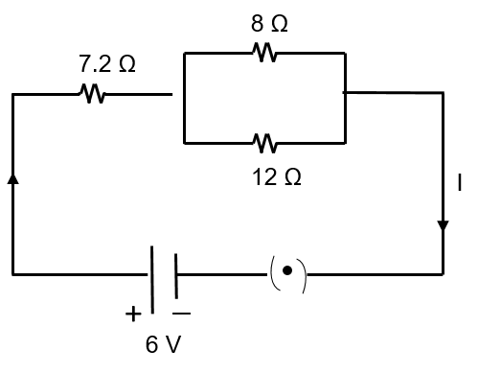

* 1. The equivalent resistance of the circuit
  2. Total current in the circuit
  3. Potential difference across 7.2 Ω resistor [4 marks]

1. An electrical appliance is rated at 1000 KVA, 220 V. If the appliance is operated for 2 h, calculate the energy consumed by the appliance in
   1. KWh
   2. Joule [2 marks]
2. (i) Write an expression for the electrical energy spent in the flow of current through an electrical appliance in terms of I, R and t.

(ii) At what voltage is the alternating current supplied to our houses

(iii) How should the electric lamps in a building be connected [3 marks]

**2011**

1. Calculate the equivalent resistance between A and B from the following diagram [2 Marks]

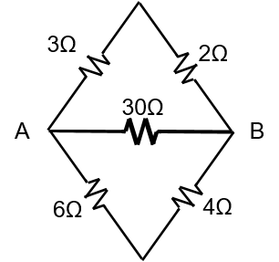

1. (i) Draw a graph of potential difference (V) vs current (I) for an ohmic resistor

(ii) How can you find the resistance of the resistor from this graph

(iii) What is a non-ohmic resistor [3 marks]

1. Three resistors are connected to a 12 V battery as shown in the figure given here.

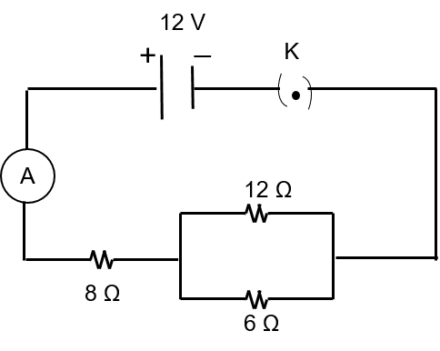

* 1. What is the current through the 8Ω resistor
  2. What is the potential difference across the parallel combination of 6Ω and 12Ω resistors
  3. What is the current through the 6 Ω resistor [4 Marks]

1. Two bulbs are marked 100 W, 220 V and 60W, 110 V. Calculate the ratio of their resistance. [2 marks]
2. (i) An electric bulb is marked 100 W, 250 V. What information does this convey

(ii) How much current will the bulb draw, if connected to a 250 V supply [3 marks]

**2010**

1. Six resistances are connected together as shown on the figure. Calculate the equivalent resistance between the points A and B [2 marks]

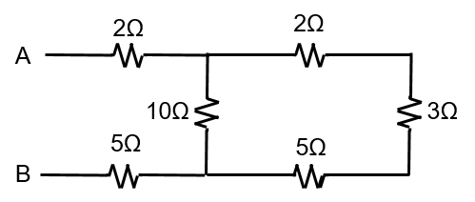

1. (i) A substance has nearly zero resistance at a temperature of 1K. What is such a substance called?

(ii) State any two factors which affect the resistance of a metallic wire [3 marks]

1. Five resistors of different resistances are connected together as shown in the figure. A 12 V battery is to the arrangement.

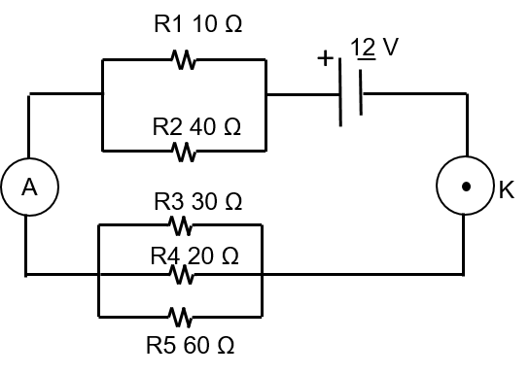

Calculate

* 1. The total resistance in the circuit
  2. The total current flowing in the circuit [4 marks]

1. Calculate the quantity of heat that will be produced in a coil of resistance 75 Ω, if a current of 2A is passed through it for 2 min [3 marks]

**2009**

1. The equivalent resistance of the following circuit diagram is 4 Ω. Calculate the value of ‘X’ [2 Marks]

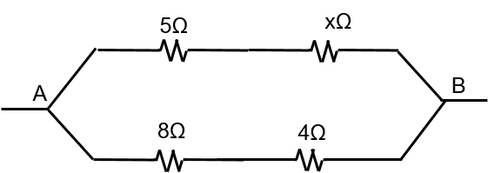

1. (i) State Ohm’s law

(ii) Diagrammatically illustrate how you would connect a key, a battery, a voltmeter, an ammeter, an unknown resistance R and a rheostat so that it can be used to verify the above law

1. An electric heater is rated 1000 W-200V calculate
   1. The resistance of the heating element
   2. The current flowing through it [2 marks]

**2008**

1. (i) Sketch a graph to show the change in potential difference across the ends of an ohmic-resistor and the current flowing in it. Label the axes of your graph
2. What does the slope of the graph represent [2 marks]
3. Three resistors of 6 Ω, 2 Ω and 4 Ω respectively are joined together as shown in the figure. The resistors are connected to an ammeter and to a cell of emf 6 V.

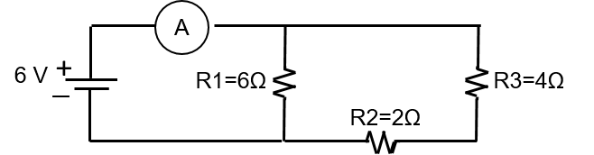

Calculate

* 1. The effective resistance of the circuit
  2. The current drawn from the cell [3 marks]

1. An electrical heater is rated 4 KW, 220 V. Find the cost of using this heater for 12 h, if one KWh of electrical energy costs 3.25 [2 marks]
2. How does the heat produced in a wire or a conductor depend upon the
   1. Current passing through the conductor
   2. Resistance of the conductor

**2007**

1. Mention two factors on which the resistance of a wire depends [2 marks]
2. The V-I graph for a series combination and for a parallel combination of two resistors is as shown in the figure. Which of the two ‘A’ or ‘B’ represent the parallel combination. Give are reason for your answer [3 marks]
3. A cell of emf 1.5 V and internal resistance 1 Ω are connected to two resistors of 4 Ω and 20 Ω in series as shown in the figure.

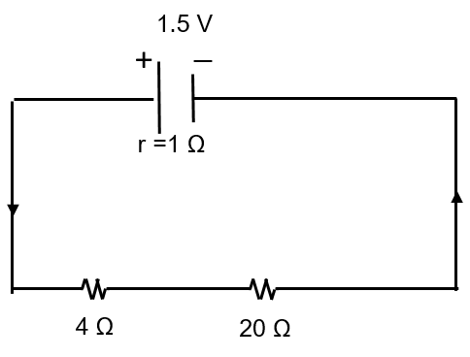

Calculate the

* 1. Current in the circuit
  2. Potential difference across the 4 Ω resistor
  3. Voltage drop when the current is flowing
  4. Potential difference across the cell [4 marks]

**2006**

1. A wire of uniform thickness with a resistance of 27 Ω is cut into 3 equal pieces and they are joined in parallel. Find the resistance of the parallel combination [2 marks]
2. In the figure given alongside, the ammeter ‘A’ reads 0.3 A.

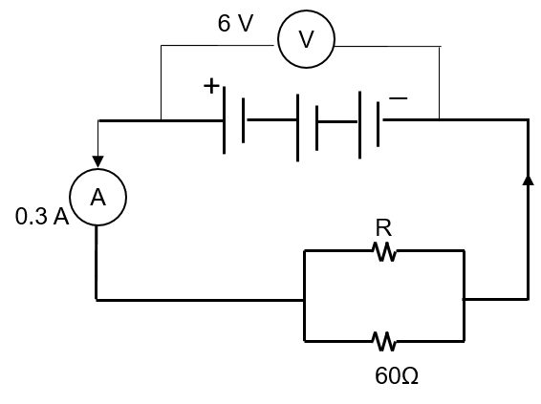

Calculate

* 1. Total resistance of the circuit
  2. The value of ‘R’
  3. The current flowing through ‘R’ [4 marks]

1. Find the cost of operating an electric toaster for 2 hrs, if it draws 8A current on a 110 V circuit. The cost of electrical energy is Rs 2.50 per KWh [3 marks]

**2005**

1. Four resistances of 2 Ω each are joined end to end, to form a square ABCD. Calculate the equivalent resistance of the combination between any two adjacent corners [2 marks]
2. In the figure given alongside A, B, and C are 3 ammeters. The ammeter ‘B’ reads 0.5 A (all the ammeters have negligible resistance).

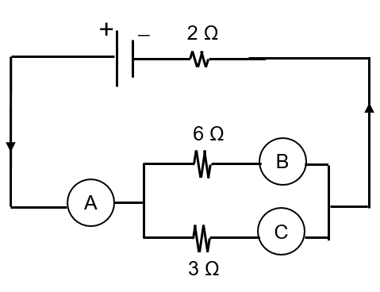

Calculate

* 1. The readings in the ammeters A and C
  2. The total resistance of the circuit [4 marks]

1. An electrical appliance is rated 1500 W, 250 V. This appliance is connected to 250 V mains. Calculate
   1. The current drawn
   2. The electrical energy consumed in 60 h
   3. The cost of electrical energy consumed at Rs 2.50 per KWh [3 marks]

**2004**

1. Mention two factors on which the internal resistance of a cell depends [2 marks]
2. An electric bulb is rated 220 V, 60 W is working at full efficiency

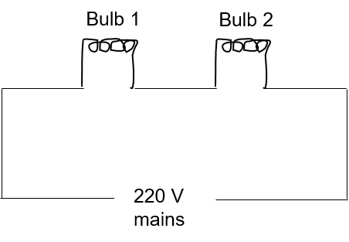

* 1. State the resistance of the coil of the bulb
  2. Another identical bulb is connected in series with the first one and the system is connected across the mains as shown alongside
     1. State the rate of conversion of energy in each bulb
     2. Calculate the total power
     3. What will be the total power, if the bulbs are connected in parallel

**2003**

1. (i) Which of the two wires of similar dimensions, copper or nichrome, would you use for the electric heater element? Give reasons to justify your answer

(ii) Two fuse wires of the same length are rated 5 A and 20 A which of the two fuse wires is thicker and why? [4 marks]

1. An electric kettle is rated 2.5 KW, 250 V. Find the cost of running the kettle for 2 hrs at 60 paise per unit [2 marks]
2. With reference to the diagram given below, calculate

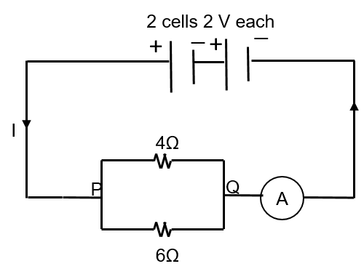

* 1. The equivalent resistance between P and Q
  2. The reading of the ammeter
  3. The electrical power between P and Q [5 marks]

1. Electrical power P is given by the expression $P=\frac{(Q x V)}{Time}$
   1. What do the symbols Q and V represent
   2. Express power in terms of current and resistance explaining the symbols used therein [5 marks]

**2002**

1. A cell of emf 1.5 V and internal resistance 10 Ω are connected to a resistor of 5 Ω with an ammeter in series (see figure). What is the reading of the ammeter [2 marks]

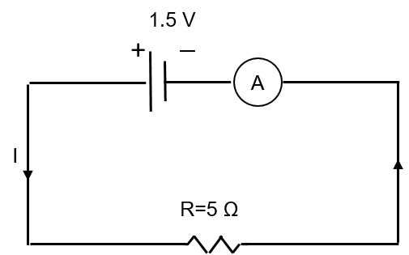

1. An geyser has a label 2 kW, 240 V. What is the cost of using it for 30 minutes, if the cost of electricity is Rs 3 per commercial unit [2 marks]
2. Make a table with the names of three electrical appliances used in your home in one column, their power, voltage rating and approximate time for which each one is used in one day in other columns [3 marks]

**2001**

1. Define the emf (E) of a cell and the potential difference (V) across a resistor (R) in terms of the work done in moving a unit charge. State the relation between these two works and he work done in moving a unit charge through a cell connected across the resistor. Take the internal resistance of the cell as ‘r’. Hence, obtain expression for the current I in the circuit. [4 marks]
2. A family uses a light bulb of 100 W, a fan of 100 W and a heater of 1000 W, each for 8 h a day. If the cost of electricity is 2 Rs per unit. What is the expenditure for the family per day on electricity? [2 marks]
3. A bulb is marked 100 W, 220 V and an electric heater is marked 2000 W, 220 V
   1. What is the ratio between the resistances of these two devices
   2. How does the power voltage rating of a device help us to decide about the type of loads (connecting wires) to be used for it
   3. In which of the two devices, a thicker connecting wire or load is required [4 marks]

**2000**

1. Calculate the electrical energy in SI units consumed by a 100 W bulb and a 60 W fan connected in parallel for 5 minutes [2 marks]